Emily Rose Skirtich
Summer 2014
GILT515
Staff Development
23 June 2014

- ISTE Teacher Objectives:
  - Given that the teachers will engage in professional and collaborative discussions, they will promote a model of digital citizenship for students
  - Given that the teachers will use the PBS and Wikispaces system, they will advocate for the diverse needs of student learners and staff members alike
  - Given that the teachers will discuss current technologies and effective ways to promote positive student behavior, they will configure a plan to implement emerging technologies to streamline student learning and teacher instruction
- Standards:
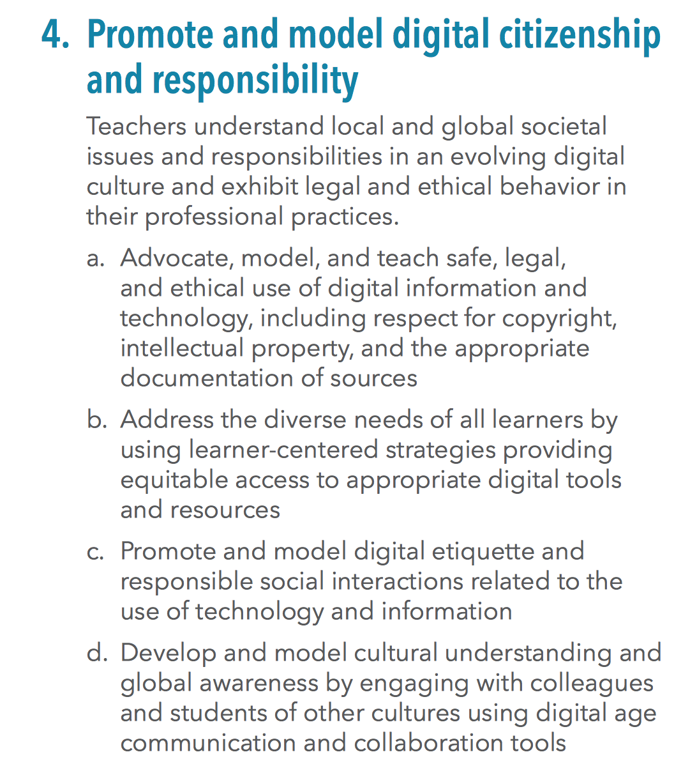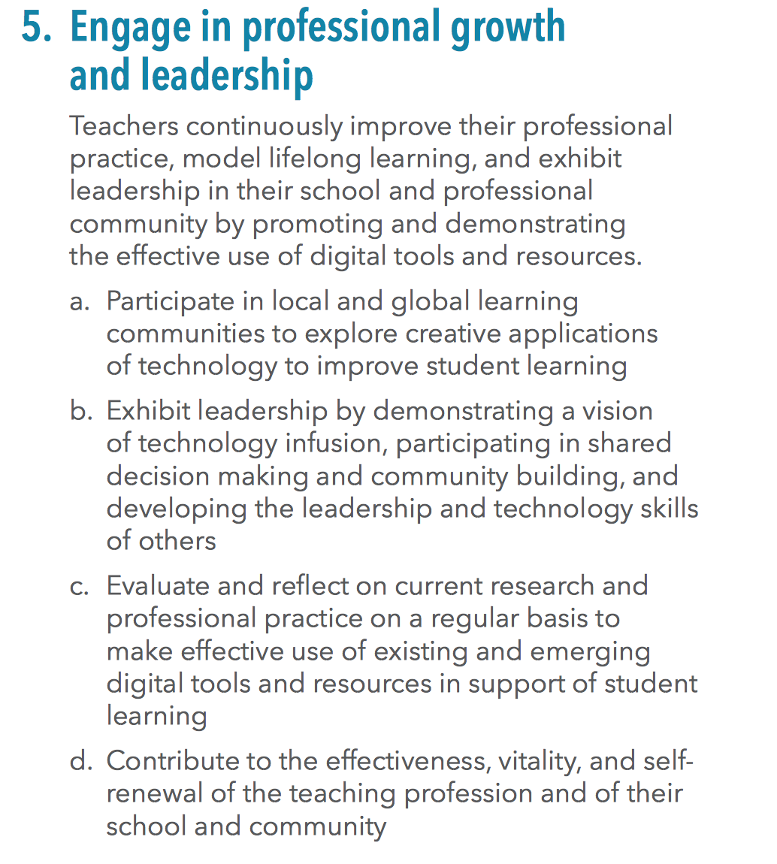
- Anticipatory set
Showcase an example of how to use the Wikispaces account to use PBS Talbot ticket system as a means to encourage positive student behavior and create a forum for faculty and staff discussions on the current technologies used in the school
- Instruction and My Teaching
  - Explaining the purpose and use of Wikispaces (Explanation)
  - Explaining the purpose and implementation of PBS Talbot Ticket system (Explanation)
  - Demonstrate collaborative discussion forums through Wikispaces technology
  - Model how Wikispaces can be used to create engaging discussions between faculty and staff as well as used as a place to showcase student projects and group work
  - Model for staff:
    - Creating a discussion forum
    - Creating a new page on a blog in Wikispaces
    - Editing the navigation page of Wikispaces
    - Upload documents, audio, files, flash, video, and content to the Wikispaces page
    - Create and manage student project pages
    - Manage student privileges on online portal
- Guided Practice:
Teachers will practice numbers 1 through 6 as listed above to ensure that they understand how to use Wikispaces program

- Individual Practice
Conducted tomorrow. In preparation, have teachers find a lesson that used PowerPoint or create a PowerPoint with lesson content. All content and presentations must be ready to go (i.e. all motion paths added, animations/custom animations added, content and graphics finalized).

- Closure
Randomly select one teacher from the seminar and ask him/her to demonstrate for the group how to create a new page in the Wikispaces program. Answer any remaining questions for staff and faculty; leave note cards for them to write anonymous questions down and address those problems/questions/comments in tomorrow’s session

Day 2 of Instruction
- ISTE Teacher Objectives:
  - Given that the teachers will engage in professional and collaborative discussions, they will promote a model of digital citizenship for students
  - Given that the teachers will use the PBS and Wikispaces system, they will advocate for the diverse needs of student learners and staff members alike
  - Given that the teachers will discuss current technologies and effective ways to promote positive student behavior, they will configure a plan to implement emerging technologies to streamline student learning and teacher instruction
- Standards:
- Anticipatory set
Review discussion about how to use Wikispaces program from yesterday’s session. The teachers will then practice creating their own pages in a forum that I have previously set up for them to refresh their memories about how to use the online portal (Practice Page Forum)
- Instruction and My Teaching
  - Demonstrate collaborative discussion forums through Wikispaces technology
  - Model how Wikispaces can be used to create engaging discussions between faculty and staff as well as used as a place to showcase student projects and group work (Video)
  - Model for staff:
    - Creating a discussion forum
    - Creating a new page on a blog in Wikispaces
    - Editing the navigation page of Wikispaces
    - Upload documents, audio, files, flash, video, and content to the Wikispaces page
    - Create and manage student project pages
    - Manage student privileges on online portal
(Modeling for Staff)
- Guided Practice:
The teachers will create their own pages and then create artificial project pages for student use. Then, they will all engage in discussions through the discussion forum application on Wikispaces to collaborate on ways to implement the PBS system with an online student presence. This conversation will continue throughout the rest of the academic year with the building principal and vice principal in charge of its direction and actions taken. The premise of these discussions are to bounce feasible ideas off of one another and to use them as the basis for future professional development seminars throughout the year.

- Individual Practice
All teachers will begin to construct their own classroom Wikispaces page and implement the technologies discussed during the discussion forum into their pages for use throughout the academic year. Teachers will upload documents, files, pictures, videos, and any other material to their Wikispaces page and continue to collaborate on the forum page with other teachers about how they use the school-wide PBS system in their own classrooms through the rest of the year.
- Closure
Answer any outstanding questions that the faculty and staff have about the Wikispaces blog program. Showcase the Q&A forum that I have setup so that they may contact me with any further questions through the academic year. If there remain a lot of questions about the program and its utilization in the school, another seminar will be scheduled to accommodate staff and faculty learning needs.

Materials
Explaining the Purpose and Use of Wikispaces:

Using Wikispaces as a platform for teachers and students yields a menagerie of benefits for schools. Some of the advantages of using Wikispaces in the school setting is that students and teachers are able to communicate more effectively with a documented conversation. This provides teachers and students a basis for their communication and provides a more effective and productive environment in which they can all collaborate on learning and projects. Also, it enables students to develop a means of communicating with their peers and teachers in a professional manner to meet their learning needs. Another great tool with the Wikispaces is that it provides teachers with a platform that allows students to edit and collaborate on projects so that sharing and editing responsibilities, which is a lifelong learning tool. Teachers also have the ability to view recent edits and changes that students make to different documents and projects, keeping up-to-date with a slew of students with various projects on the horizon. For teachers who encourage multiple stages of writing or projects, it helps the students with the editing and staging process which can prove to be invaluable for the students to submit different stages of projects and writing pieces. Lastly, Wikispaces is a great platform for teachers to use in the classroom because it has no prearranged structure. This benefit to the program is that teachers’ creativity will not be stifled and they can manipulate the layout of the webpage to suit their individual needs for each of their classes. As most teachers value innovation and creativity, that is a crucial element to maintaining their own teaching preferences, even in the online setting.

Adapted sources: http://kingofbeasts.wikispaces.com/Advantages+and+Disadvantages
Explaining the purpose and implementation of PBS Talbot Ticket system
The PBS Talbot Ticket system is a new initiative introduced to the middle school this year to encourage more positive behavior from students. One of the ways that the administration encourages the students to behave well is the Talbot Ticket system, which allocates Talbot Tickets to students who demonstrate a following of the PBS system standards. At the beginning of the academic year, the faculty, staff, and students are introduced to the reward system and standards that they will enforce throughout the year. The students will participate in Advisory groups once a month the engage in various discussions and activities related to the PBS system and standards and how they play an active role as contributing members to the program. The motto for the PBS system for this school year is Rise Above the Rest with competencies in Positive Attitude, Respect, and Responsibilities in the Locker Room, Hall, Cafeteria, Cyber Space, and School Bus. The students are held to a standard of excellent behavior in every aspect of their life as a student at the middle school, and by following the rules and acting like mature, responsible citizens, they can earn Talbot Tickets for their good behavior. They are then entered into a drawing on 10x10 grid on bulletin board in front of the main office. Once there are 10 students’ names in a row (similar to the concept of Bingo) then those students are the lucky winners of winning a prize from administration. Some of the rewards that the school issues are free sporting event tickets, early admission to school dances, gift cards to local eateries, and other rewards that entice students to behave.
Advisory Forum Page: http://htsdadvisorywiki.wikispaces.com/First+Day+of+School+Program

YouTube video about the use of Wikispaces: https://www.youtube.com/watch?v=J6Vo3JJB7uQ
Managing Wikispaces for Teachers
Creating a discussion forum
Creating a new page on a blog in Wikispaces
Editing the navigation page of Wikispaces
Upload documents, audio, files, flash, video, and content to the Wikispaces page
Create and manage student project pages
Manage student privileges on online portal
Follow these steps for all of the above mentioned functions:
    - First, visit the page that you want to create a new page from. This page will be your anchor page
    - Next, go to the upper right hand corner of the page and click on “edit”
    - After selecting “edit,” choose the “link” option
    - Then choose what you want to link your new page to. You can choose a file or document, another page within the Wikispaces page, a document you have created, an e-mail address, a URL address, or another widget.
    - Click “save” and then “preview.”
    - There is a Q&A option for the discussion forum page that you can opt to include on your new webpage
    - Depending on the function that you want to include on your new webpage, there are multiple widgets that you could choose to include on your new webpage. Browse the options to see which widgets would work best for you and your classroom needs.
Evaluation: The teachers were engaged in professional discussions to discuss the PBS system of the Talbot ticket system for the academic year. Moreover, the teachers collaborated on ways to use new innovations in technology in their teaching through the use of the Wikispaces website in which they created a forum for the uses of technology within the school setting. The faculty and staff promoted digital citizenship for the students by using the technology and digital information in a responsible manner. As users of the technology within the classroom, the teachers demonstrate strong leadership skills in the classroom for the students to emulate in their own technology practices. The students research and use different technology skills, so teachers must discuss and analyze the various strategies that support and encourage student learning through the use of technology and innovation. However, simply because technology is readily available in the classroom does not mean that student learning falls second to the implementation of learning. Rather, student learning remains at the apex of the teaching model regardless of the strategies executed in order to achieve higher levels of student learning and acquisition. For the post-test, the teachers, faculty, and staff discussed the Wikispaces online platform that the school sponsors for the teachers’ and students’ use as a means for communication and online collaboration within different courses.
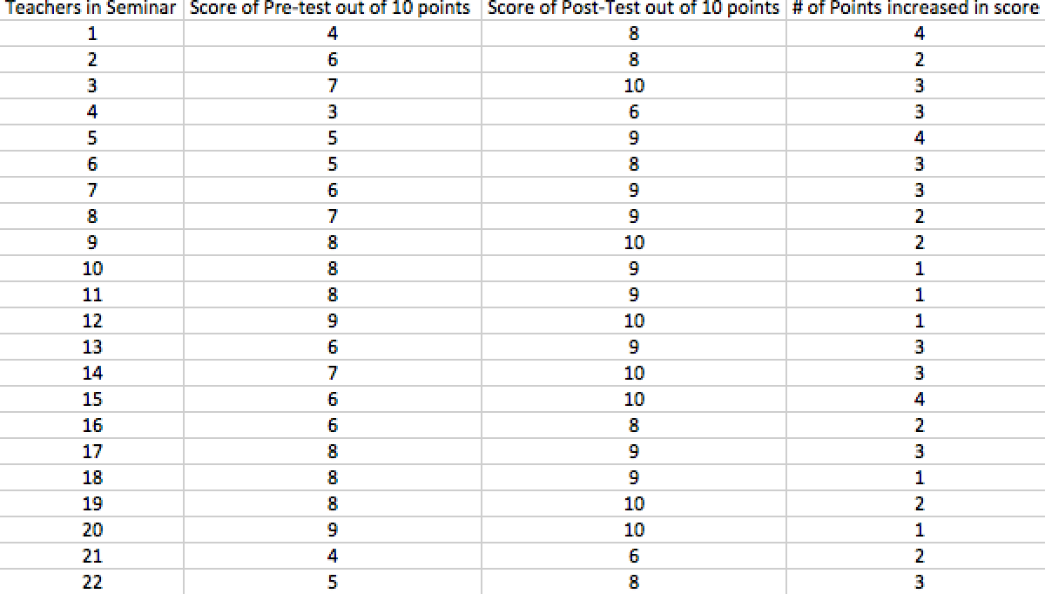
As you can see from the data displayed in the chart above, most of the teachers were a bit wary of the new technology that the Wikispaces program had to offer to the faculty and staff. Despite its injunction this past September at the start of the academic year, there was not an abundance of follow-up with the technology so many of the teachers abandoned the technology and refused to use it since they felt as if there was no professional development and support within the school community. The teachers demonstrated proficiency with the programming with the assistance of the handouts and videos that was provided since they value reinforcement and support especially since many of the faculty and staff do not feel confident in their own abilities with the technology in the school system. If I were to repeat this professional development again, I would most likely add even more step-by-step instructions for how to use the Wikispaces platform and the various functions that can be utilized within the classroom setting. One of the most crucial parts of the seminar did not occur during the seminar itself, but rather it was the follow-up in the Q&A forum that followed the seminar in which teachers could return to the online portal forum and ask a question to the IT Specialist and Integrator later on in the year in case anything cropped up after the seminar was over. This is one of the most important elements of providing professional development for teachers; readily available resources and constant reinforcement and follow-up from the IT Specialist so that they feel comfortable with the technology and use it whenever they can in the classroom to enhance student learning. Overall, I enjoyed instructing professionals but I much prefer teaching students about technology since they generally are more eager to learn.

