Name:_________________­­­­­___­­­­­_________

Miss Skirtich

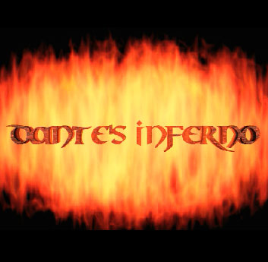23 January 2018

English 10: World Literature



**Dante’s Inferno Webquest**

You are to submit a single, completed webquest. The final submission should be typed on a separate sheet of paper. The answers to your webquest should be in *complete sentence* form—I should not need this sheet to understand what is being discussed. These answers should reflect the depth of your research.

Total value: **140 pts**

**Dante Alighieri: A Poetic Descent into Hell (2 pt each**)

Use the following websites to locate information concerning Dante’s life and works:

<http://www.worldofdante.org/inferno1.html>

<http://www.greatdante.net/commedia.html>

<http://www.greatdante.net/time.html>

<http://www.sparknotes.com/poetry/inferno/facts.html>

**The Man:**

1. Give the dates of Dante’s life.
2. Where did Dante call his home?
3. Who was the great love of Dante’s life and the inspiration for many of his poetic heroines?
4. Who was Dante’s wife? Did she have an influence on his literature?
5. What occupations did Dante hold during his lifetime?
6. To what political party did Dante belong?
7. What tragedy befell Dante in the year 1302? What powerful historical figure is involved?
8. What literary contemporaries are born during Dante’s later life? Give a brief description of their accomplishments and at least one of their famous works. (use Google)

**The Divine Comedy: (2 pts each)**

1. How long is the *Divine Comedy*?
2. What was the original title of the work?
3. Who suggested the addition to the title? And why?
4. What genre of poetry is this masterpiece?
5. What is the purpose of the *Inferno* and its companion pieces?
6. What were some of the influences that helped to shape the *Divine Comedy*?
7. When was the *Inferno* published?
8. In what language was the poem published?
9. What verse form was the poem written in? Define this form.
10. Give a brief summary of the *Inferno*.
11. What is the fictional date that the *Inferno* begins?
12. Explain the symbolic meaning of Dante, Virgil and Beatrice.

**Do I know you, fair shade? (3 pts each)**

Identify the following figures and locales from mythology, literature and history:

Some, but not all of these are referenced on this site--<http://www.sparknotes.com/poetry/inferno/>

1. Acheron
2. Styx
3. Charon
4. Virgil
5. Minos
6. Francesca and Paolo de Rimini
7. Pope Boniface VIII
8. Filippo Argenti
9. Ulysses
10. Archbishop Ruggeri
11. Count Ugolino
12. Fra Albergio
13. Branca d’ Oria
14. Judas Iscariot
15. Brutus
16. Cassius

**Vocabulary Corner:** Define the following words using an online dictionary. **(2 pts each)**

1. Allegory
2. Persona
3. Contrapasso-
4. Avarice
5. Heretic
6. Pinnacle-
7. Pagan
8. Treason
9. Hoard
10. Bolgia
11. Malbranche

**Complete either task 1 or task 2.**

**Task 1: Chronology across the Medieval Period: (30 pts) 10 BONUST POINTS FOR #1** [You may choose to complete this on poster board or bulletin board paper.]

Create a timeline that spans Europe during the medieval period.

Note when the Renaissance began in each part of Europe and note important events that take place during these time periods. Include illustrations when possible.

**Task 2: Virtual Tour:** <http://www.worldofdante.org/maps_main.html>

(view the key to help decipher each circle) **(30 pts)**

Take a tour of the *Inferno* on the website above. Record the type of sinner Dante and his guide will encounter in each level. Be sure to read the text offered on each ring as some circles are host to more than one type of sinner. Also, record any additional land marks that appear in each circle and explain their significance.