Romanticism and Revolution
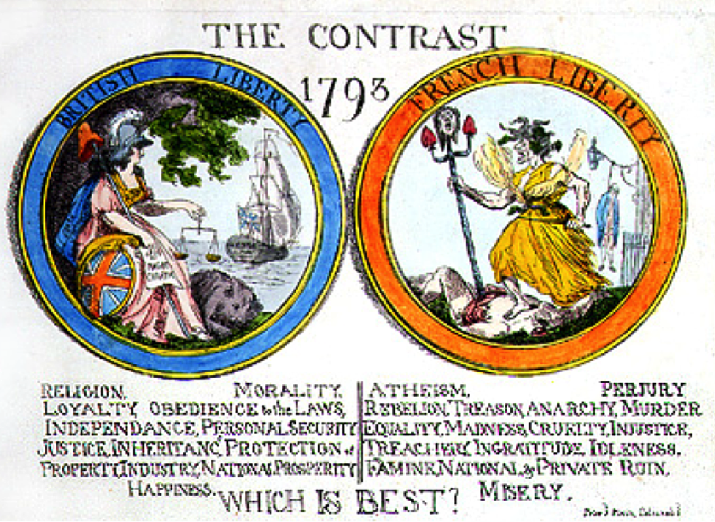

This political cartoon by James Gillray (1757-1815) illustrates the difference between opposing political views of the French Revolution by contrasting a dignified British freedom with the events of the Reign of Terror, or the rule of fear masquerading as liberty.
The French Revolution is widely recognized as one of the most influential events of late eighteenth- and early nineteenth-century Europe, with far reaching consequences in political, cultural, social, and literary arenas. Although scholars such as Jeremy Popkin point to more concrete political issues as grounds for the upheaval, supporters of the Revolution rallied around more abstract concepts of freedom and equality, such as resistance to the King’s totalitarian authority as well as the economic and legal privileges given to the nobility and clergy. It is in this resistance to monarchy, religion, and social difference that Enlightenment ideals of equality, citizenship, and human rights were manifested. These beliefs had profound influence on the Romantic poets.
The Revolution affected first- and second-generation Romantics in different ways. First-generation poets such as William Wordsworth, Samuel Taylor Coleridge, and Robert Southey, the most well-known members of the “Lake District” school of poetry, initially sympathized with the philosophical and political principles of the Revolution, particularly as expressed by William Godwin in his Inquiry into Political Justice (1793). Wordsworth famously chronicled his response to the war in his Prelude, although the relevant passages were not published in full until after his death in 1850. One shorter section, however, made its way into print in 1809 under the title “French Revolution, as it Appeared to Enthusiasts at Its Commencement.” The phrasing of the title indicates Wordsworth’s turn toward more conservative politics later in life, particularly after the bloody turn of the revolution.
According to Simon Bainbridge, Wordsworth and Coleridge translated the Revolution’s emphasis on man’s equality into the “language of the common man” and “low” subject matter found in Lyrical Ballads. Wordsworth’s everyday language and subject choices look like a literary revolution that mirrors the historical revolution by breaking down the boundaries that separated poetry - with its elevated characters, plots, and diction - from ordinary representation.
While first-generation Romantics saw their revolutionary fervor tempered by the gruesome turn of the revolution from the execution of Louis XVI through the Reign of Terror, second-generation Romantics such as Lord Byron and Percy Shelley held to the Revolution’s principles in a more idealistic, if somewhat cautious way. Shelley, for instance, portrays rebellious events in poems such as Prometheus Unbound (1820), Swellfoot the Tyrant (1820), andHellas (1822), yet he avoids direct representation of revolutionary action through a mythological framework. This framework, according to Jeffrey Cox, serves a two-fold purpose: to avoid the appearance of promoting violent revolutionary action and instilling despair in those who still promoted the cause of liberty throughout Europe. The latter Shelley sees as the primary fault with Wordsworth’s abandonment of radical libertarian ideals and adoption of more passive solutions, while the former is characteristic of Shelley’s critique of Byron’s representations of revolution as deteriorating into predestined violence and despondency. Shelley, above all, sought to promote the ideals of liberty and equality through non-violent revolution. Furthermore, Cox argues that Byron’s portrayal of inevitable, cyclical patterns of violence is representative of an inability to break free of the past. In this way, Cox interprets the revolution in Marino Faliero as doomed by the hero’s inability to overcome the past, which leads the rebels to mimic the actions of the aristocracy which they are trying to overthrow. This cynical view of radical action is reflective of Byron’s own attitudes toward the French Revolution, particularly his youthful idolization of Napoleon Bonaparte, whom he later criticized for regressing from liberty and democracy into monarchical dictatorship.
Shannon Heath

Select Bibliography
Bainbridge, Simon. “Politics and Poetry.” The Cambridge Companion to British Literature of the French Revolution
in the 1790s. Pamela Clemit, Ed. Cambridge University Press, 2011.
Cox, Jeffrey N. “Romantic Drama and the French Revolution.” Revolution and English Romanticism. Keith Hanley
and Raman Selden, Eds. New York: St. Martin’s Press, 1990.
Popkin, Jeremy D. A Short History of the French Revolution. 4th ed. New Jersey, Pearson Prentice Hall, 2006.

